NUTRITION SELF ANALYSIS
Name
Institution
Date

My weight according to the BMI formula is given as:
BMI = weight (kg)/Height^2 (cm)
Weight = BMI*Height^2
= 119lbs
And the Hamwi method gives my weight as follows. For a female like me, the weight is calculated as (Hayward et al., 2009):
F= 100lb for the first 5 feet + 5lb for every additional inch
Since I have a height of 5 feet and 8 inches,
Weight = 100+5+5+5+5+5+5+5+5 i.e. 100 + (5*8)
= 140lbs
BMI = (119*0.454) / (5’8*0.3048) ²
= 53.9775/3.1252582656
= 17.27
BMI = 63.5029/3.1252582656
= 20.319
The below screenshots represent my diet for three consecutive days: 19th, 20th and 21st of June this year.
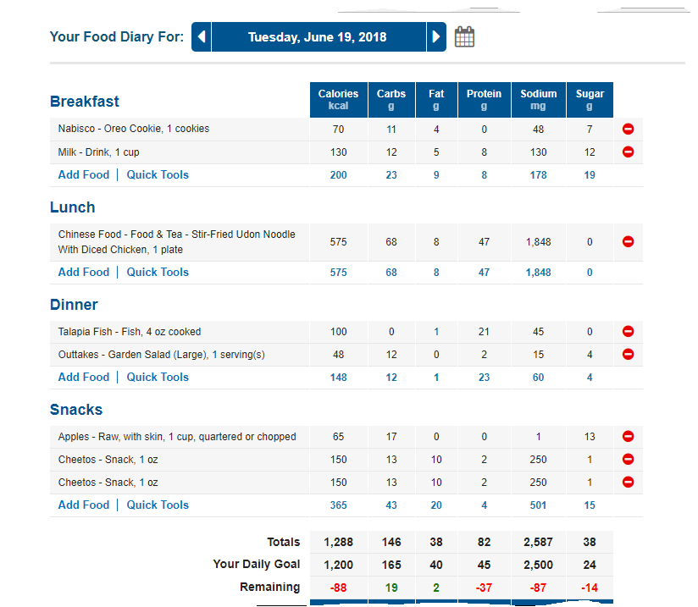

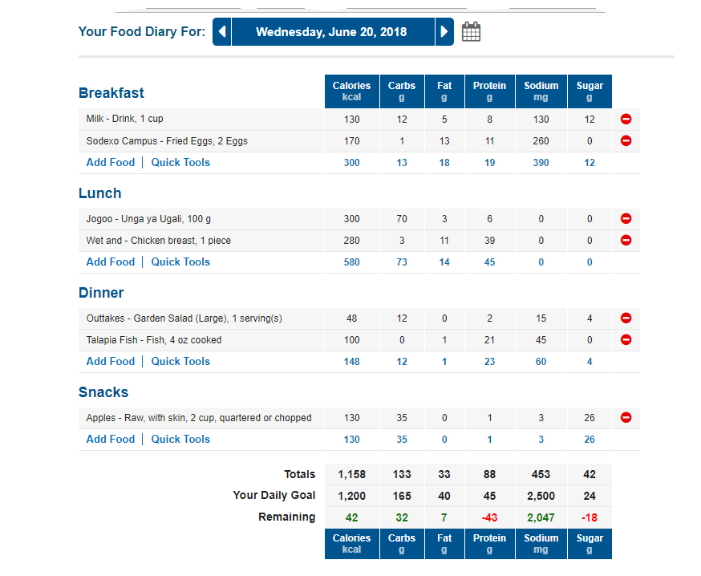

My current BMI is 17.27 according to the BMI and 20.319 as per the Hamwi formula. Normal BMI ranges between 18.5 and 25. According to Pickkers et al, a range of 16 all the way to 18.5 is an underweight situation (2013). This is where my realistic BMI lies. Hamwi BMI reads 20.319 which is considered an exaggeration. According to the food dairy count down, my purposed calorie goal is 1200 calories in a day. The food specify and requirements is clearly depicted in the screenshots thereafter. Considering the food I take, I am healthy although my weight needs to be worked on.
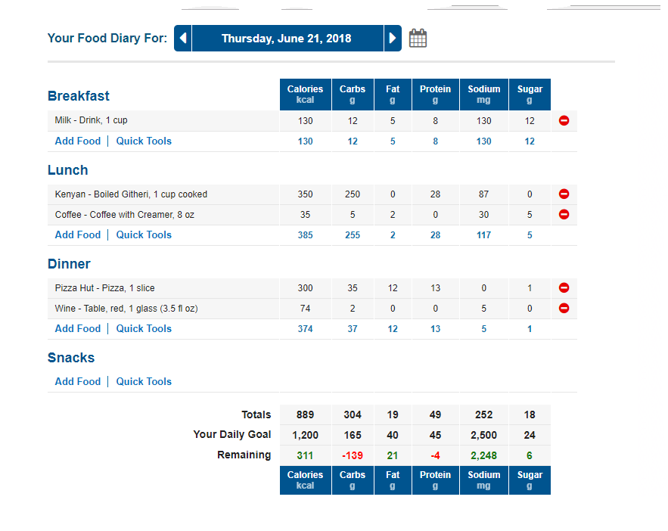
I can sum up this report by connoting that I do not reach my food target that is supposed to maintain my health at the standard levels and to maintain my body weight. My nutritional intake analysis for the three days is as follows. Carbohydrate intake for the first two days does not reach the purpose goal. On 21st, the third day, I exceeded its intake by 139 grams.
My recommended carbohydrate allowance on a daily basis is 165g. Dudek, argued that a definite range that is enough is ought to be the Acceptable Macronutrient Distribution Range (AMDR), (2014). There is the need that I improve on my carbohydrate intake, considering that carbohydrates are energy giving foods, as such, one cannot keep the health their bodies requires if standards of their diet are not kept.
Fat intake: my fat intake is below the daily requirement of 40. In the three days, it is only the second day that neared the goal requirement. Critically looking at the situation here, fats are contained in nearly all the foods that I take. The problem comes in the quantity of food taken. If I increase my quantity, then my fat content will get to the desired level.
Protein intake: proteins are body builders. I have taken them above my daily target of 45grams. I take milk, chicken and fish a lot (Dudex, 2014). They are very yummy and make my meals tasty. I can do less of them but I cannot completely do without them. I know I have to work hard to reduce the protein intake and make adjustments to my carbohydrate intake. In this dairy, all the days were characterized by excess proteins. Milk was my order in the morning, and then pizza, chicken or fish during lunch or dinner. I still feel the need of doing a metabolism status check. For the second day for instance, I took milk, chicken breast, fish and eggs and the third day milk and fish. I think this quantity was enough for the day.
Fiber: fiber intake was low. I didn’t find the essence of fiber foods in my diet. Those that I ate were as a result of keeping the diet balanced. Besides, they were contained in the other foods that I consumed.
Sugar: I realized that I am falling short of nearly all nutrient distribution range according to my estimate calorie requirement. Sugars are classified as the contributors of obese and this made me so sensitive to sugary foods. I tried to keep my daily targets though I did not reach desired levels. Actually most sugars I consumed came from natural fruits, the apple.
Saturated fat: one of the most key ingredient that I consider when buying my foods is the saturated fat content (Dudek, 2014). This is because of the other fats, I find it difficult consuming them directly. This explains why my saturated fat consumption was bad off. Actually in the first day of the dairy, I exceeded the recommended amount.
Polyunsaturated fat: some of the foods I have taste on have polyunsaturated fat that I cannot get off. The recommendations of these fats according to myFitnessPal is 0 but this seemed difficult to attain form my diet analysis. The intake in the second day was alarming and this is a contributor to my underweight situation.
Monounsaturated fat: monounsaturated fat is deemed healthy to the body’s cholesterol levels. Dudek says that saturated fats can be replaced with monounsaturated for healthy blood flows and reduce cardiac attacks (2014). The consumption of these fats was not bad in the 3-day diet.
Trans Fats: these are said to be unhealthy. LDL cholesterol levels should be maintained below 100mg/dl. With the consumption of LD fats, these levels are increased which is a threat to a healthy body. My consumption for them was totally controlled by the disciplined diet I kept.
Cholesterol: for the first 2 days, cholesterol consumption seemed unregulated with intakes exceeding the recommended ones. The third day, I maintained a high discipline to offset the much I had taken as I began the Dairy.
Sodium: As a young person, my sodium consumption levels are not supposed to go above 2500 mg in a day. The only mistake I have had on this dairy journal was the first day where is exceeded my RDA. The other days were characterized by natural clean waters and sea salts that are free from this element.
Potassium: this is the mineral that I was so keen on, though unaware. I did not exceed the required levels but its consumption was a bit low. I am seeking to take a wide range of fruits and vegetables so that I can increase its level for the development of strong joints and teeth.
Vitamin A: Vitamin A is crucial in the body. My intake for vitamin A was very good in the first 2 days of the start, but on the third, I went absolutely down. I target finding more fruits that can replace some proteins in my diet to maintain a healthy lifestyle.
Vitamin C: my diet had no sources of Vitamins C in it. This led to low levels of its consumption. I know good vegetables that can add Vitamin C content to my diet, I will consider them.
Iron: I took chicken and fish but my diet analysis was considered poor in iron. Iron is a component of the blood and its function can be hindered by the low levels of its intake. I will take the initiative and consume foods rich in Iron e.g. tree tomato fruit and cereals and floor that have been fortified.
Strengths and weaknesses
The major strength that I can talk about is my scrutiny and a lot of keenness in finding the right meals for my diet. My finding connote that my proteins were of quality since a bunch hit the recommended levels within the three days. Pizza, chicken and fish were the major proteins in dwelt on. Taking water was also very crucial and helped me in the absorption of the meals I took. For a healthy body, one should take between 1750ml-3000ml of fluid every single day (Dudek, 2014, p. 124-125). I could take 8 cups of water every day. I never slack when it comes to water because of the healthy body that I want to maintain.
The major weakness in my diet is the inconsistency. Today I might consume a balanced diet but tomorrow, I be careless in my meals. I have totally failed to maintain the Vitamin levels required throughout this dairy. Also, other nutrient like potassium, sodium and iron have been carelessly considered in my diet. I have learnt a strategy that I will keep to maintain a consistent and a balanced diet.
Medication
I was not under any medications or any treatment.
Culture
I live in a town where there are mixed cultural backgrounds and therefore, I have no specific one that I would hold to regarding to my eating habits.
Diet Plan
Guided by the realistic BMI of 17.27, I need to gain some weight so that I fit on the range of normal people. Despite the feelings of unhealthy, and eating pretty well, I have a condition that needs a nutrition advice – underweight. I need to gain over 3.5 kg in order to gain the normal BMI. As a result, I need to consume more fats and proteins to build my body. I have a feeling that I should increase the quantity I take and my target will be arrived at. Sugars and salts will be minimized in my diet and water intake maintained. With the increased protein and fat content, I will need a little bit of exercise to minimize chances of getting obese (Dudek, 2014).
Implementations
My goals and desires during are well spread in the remaining weeks and months of this year. I want to learn the act of practice at least once in a week. By November, I should have attained a weight of above 7 kg. I will include sweet potatoes, mushrooms and cereals in my diet, not forgetting fruit varieties. Being a student constrains most goals that I put since time schedules collide with classes. I will try much to leave my dream and overcome this obstacle.
I also want to take snacks that are wheat free. I have a slim tender body which I want to maintain. My extra kg should be flesh in biceps and my back region. By the same date, I will have developed the habit of taking snacks during lunch hour other than yummy foods.
Refection
MyFitnessPal has been a very key application for the maintenance of my body overall shape. People have advised a lot on what I should be taking, including my parents but I have maintained what fits me according to this app. It has developed a food intake discipline in me. Initially, I used to eat just because I want to, these days I eat when I have to. My calorie requirements are clear to me, this simplifies every step that I want to take concerning my meals.

References
Dudek, Susan, G. (2014). Nutrition essentials for nursing practice. Philadelphia: Lippincott Williams & Wilkins.
Hayward, M. C., & Shea, A. M. (2009, August). Nutritional needs of patients with malignancies of the head and neck. In Seminars in oncology nursing (Vol. 25, No. 3, pp. 203-211). WB Saunders.
Pickkers, P., de Keizer, N., Dusseljee, J., Weerheijm, D., van der Hoeven, J. G., & Peek, N. (2013). Body mass index is associated with hospital mortality in critically ill patients: an observational cohort study. Critical care medicine, 41(8), 1878-1883.

